**NORTH WEST REGIONAL COLLEGE**

**DEPARTMENT OF SCIENCE TECHNOLOGY AND CREATIVE INDUSTRIES**

**WORK BASED LEARNING - WEEKLY REPORT**

**NAME:** Sean Carlin

**REPORT NO:** 10 **DATE:** 8/05/2020

Please use the space below to give details of your activities for this report period. Your outline should include - in as much detail as possible, **a breakdown of activity by project**. You should aim to address areas such as perceived organisational benefits, desired outcomes and deliverables.

For each project that you are working on – you should indicate the title, progress, targets met and expected completion date.

**Summary of activities:**

Since my solution is completed, this week I had to design and create the Tutorial document (user guide) for the clients that are getting my solution. During the process of this document I didn’t have any issues as I learned to create a user guide during my visual programming module. Taking this experience on board with me during my placement has really benefitted me and made things a lot easier, it has also improved my current skills! For specific parts of the tutorial document, there will be graphical imagery so it will be easier for the user when setting up this function. You can see an example of this below:

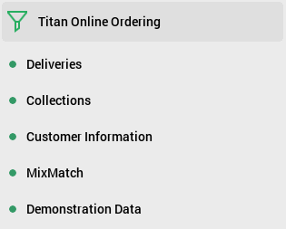

**Starting the Demonstration Data Method**

**Select ‘Functions’**

**Select ‘Demonstration Data’**

Overall actually developing a user guide for a live company that will use these for years to come is personally rewarding, at the same time it has helped me practice this skill I learned from my course, enhancing it within a live business to carry with me to future placements to come.

**Comments on progress:**

I enhanced my user guide skills and learned how to develop one to business specifics. Not much else has been learned this week as my solution is now complete and fully tested.

**Planned tasks:**

Finish up with the tutorial document and have it evaluated and checked over by my mentor.